Decrypted Jason
{
"crmId": "100000028681",
"customerId": "6456318778592384168",
"agentId": "376210",
"isConsentAccepted": "Y",
"isRepush": "Y",
"psmDetails": {
"productType": "Non-POS",
"isRecommendedProduct": "Y",
"isSolution": "N",
"recommendedProducts": [
"Max Life - Saral Pension Plan, Life Perfect Partner Super, Guaranteed Lifetime Income Plan, Flexi Wealth Advantage Plan, Fast Track Super, Saving Advantage Plan, Smart Wealth Plan, Monthly Income Advantage Plan, Smart Wealth Income Plan;Bajaj Allianz - Guaranteed Pension Goal;LIC - SIIP, Nivesh Plus, New Endowment Plus, Jeevan Labh, Jeevan Umang, Jeevan Tarun, Jeevan Anand, Bima Jyoti, Dhan Rekha;"
],
"selectedProduct": "184",
"selectedProductName": "Smart captial",
"income": "800000",
"lifeStage": "0",
"riskAppetite": "Low",
"goalSelected": "retirement"
},
"additionalData": {
"isNumberIndian": "Y",
"isLIEqualsPH": "Y",
"dobOfInsured": "",
"education": "Post Graduate",
"occupation": "Salaried",
"hasExistingLICover": "N",
"leadSourceOption": "Others",
"insuredFirstName": "",
"insuredMiddleName": "",
"insuredLastName": "",
"insuredGender": "",
"relationWithProposer": ""
},
"customerProfileData": {
"agentDetails": {
"agentName": "Rakesh Ravindra Mandape",
"agentEmailId": "test@axisbank.com",
"agentPhoneNo": "1234567890",
"agentRole": "Bharat Banking:Sales Manager - Bharat Enterprises"
},
"bancaDetails": {
"branchCode": "0349",
"branchName": "HADAPSAR PUNE",
"customerSegment": "CCAGR",
"schemeCode": "PBNRE",
"constitutionCode": "01",
"ukycFlag": "N",
"spCode": "SP0069045948",
"kycStatus": "Y",
"omniFlowLink": 0,
"offerId": 0,
"offerName": "Life insurance",
"crmStatus": "100059",
"accountDetails": {
"accountNo": "978010300000123",
"accountOpeningDate": "2015-11-20",
"accountType": "Savings",
"ifscCode": "UTIB0000333"
}
},
"communicationAddress": {
"address1": "1st Floor",
"address2": "M-12 Housing Board",
"city": "PUNE",
"state": "maharashtra",
"country": "India",
"pinCode": "411017"
},
"permanentAddress": {
"address1": "Housing Board",
"address2": "Sastri Nagar Yarwada",
"city": "PUNE",
"state": "maharashtra",
"country": "India",
"pinCode": "411017"
},
"customerDetails": {
"customerTitle": "mr",
"firstName": "Anil",
"middleName": "Kumar",
"surName": "Yadav",
"dob": "1990-01-01",
"gender": "M",
"pan": "HFDPG2568X",
"mobileNumber": "8800260888",
"emailAddress": "user100353568@test.com",
"stdOffice": "",
"stdOffice1": "",
"telNo": "",
"telNo1": "",
"ckycNo": "60030814551737"
},
"additionalData": {
"data1": "",
"data10": "",
"data11": "",
"data12": "",
"data13": "",
"data14": "",
"data15": "",
"data2": "",
"data3": "",
"data4": "",
"data5": "",
"data6": "",
"data7": "",
"data8": "",
"data9": ""
}
}
}

Encrypt the JSON
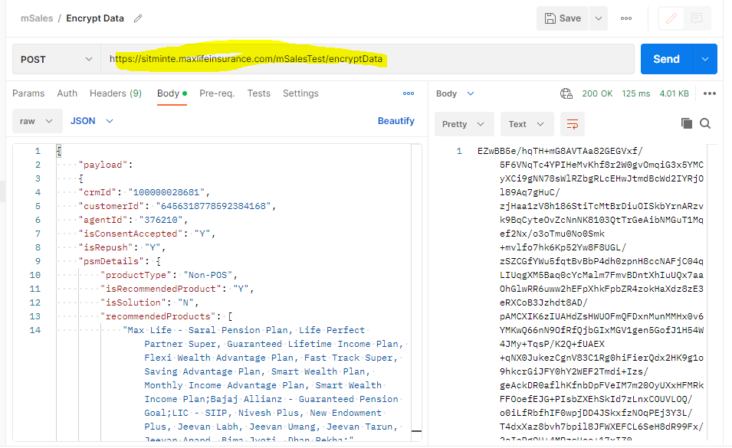
Push JSON into mSales
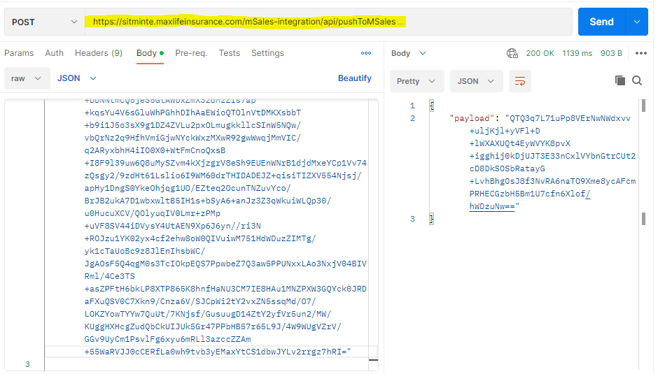

Encrypt the Credentials
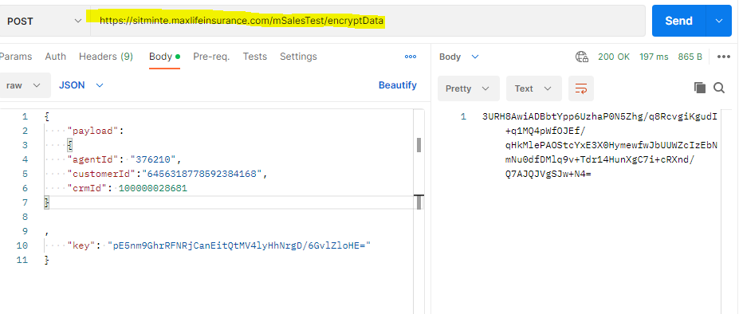

Login into mSales UI
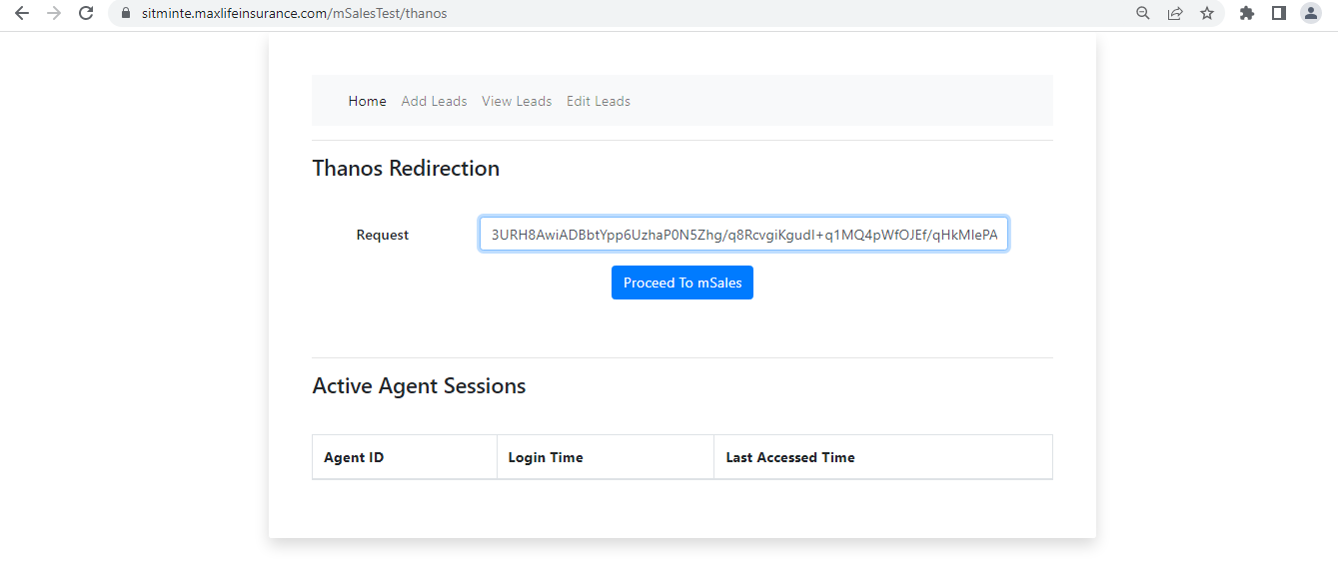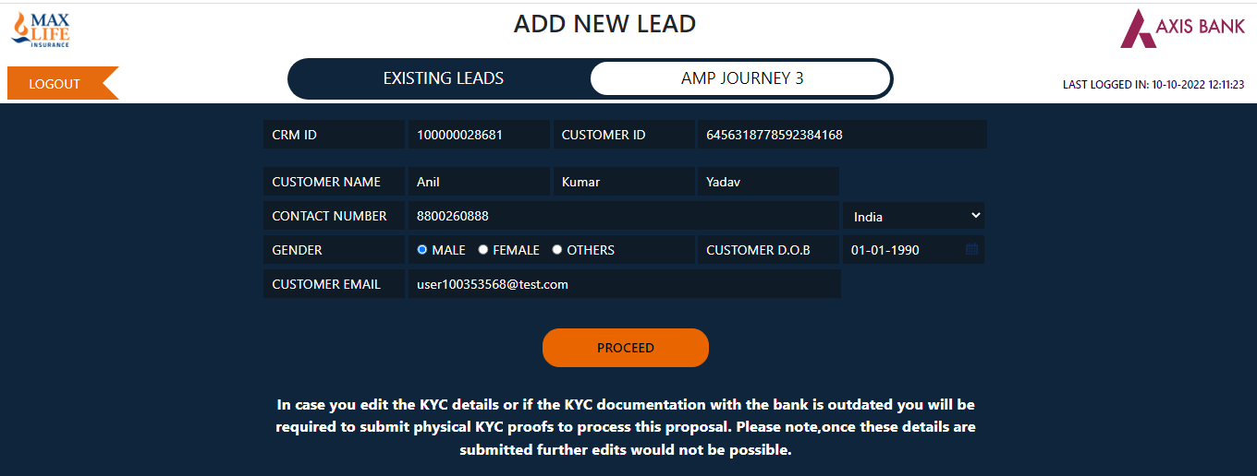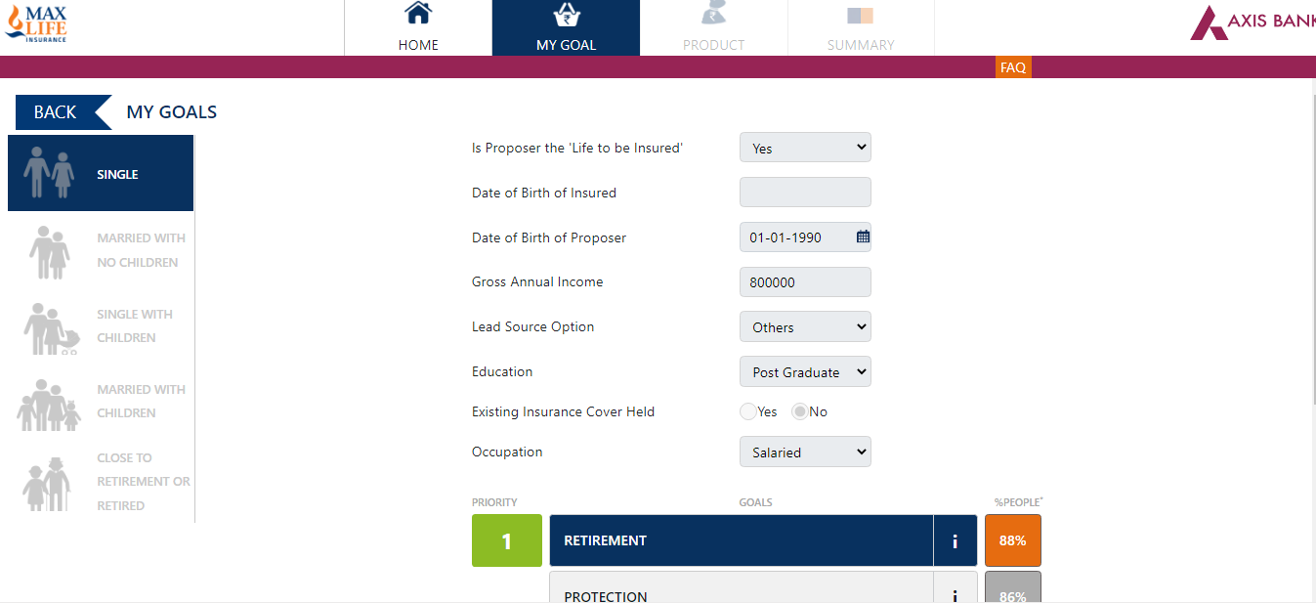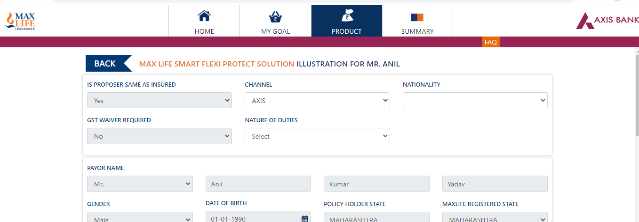
Cross th URL
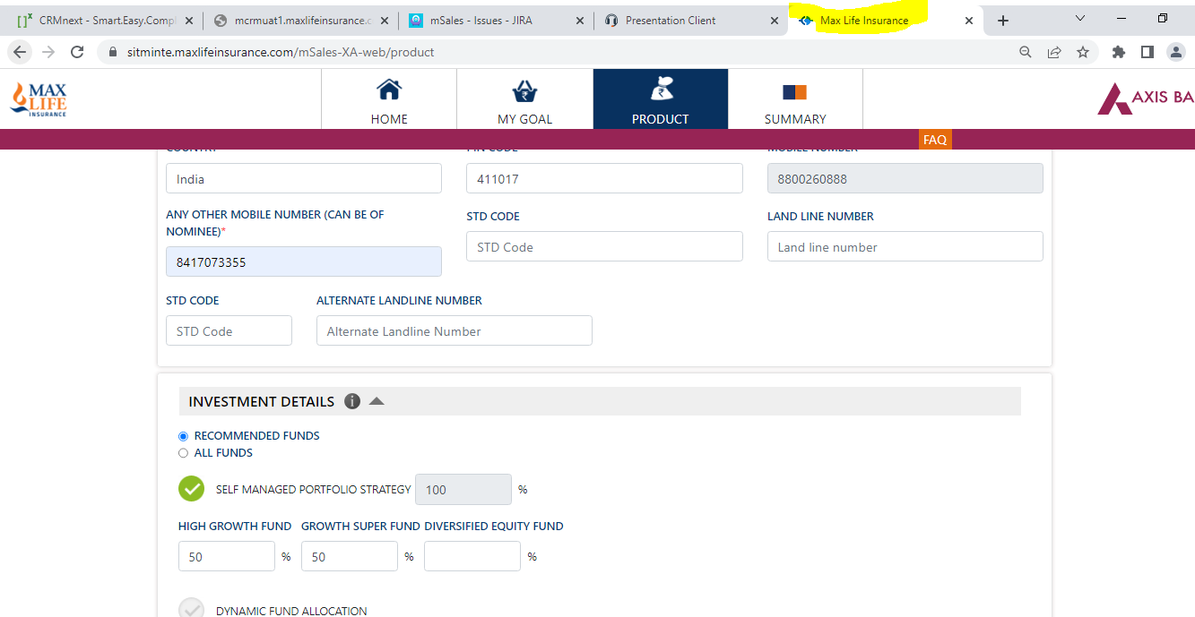

Go to mSales API Encrypt IS invalid Lead as Y
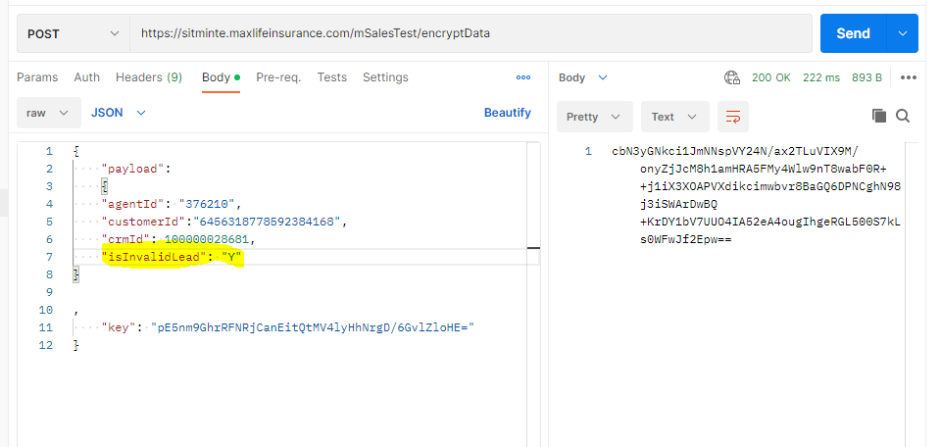
Push into Msales
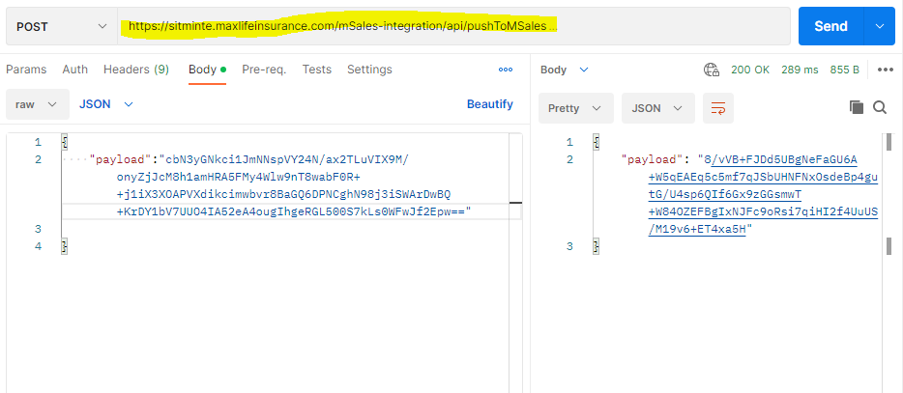
Encrypt the credentials
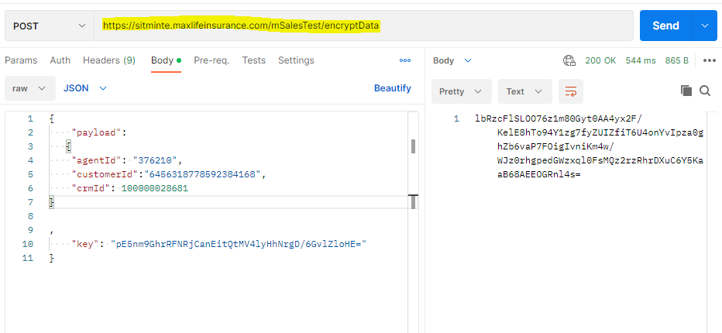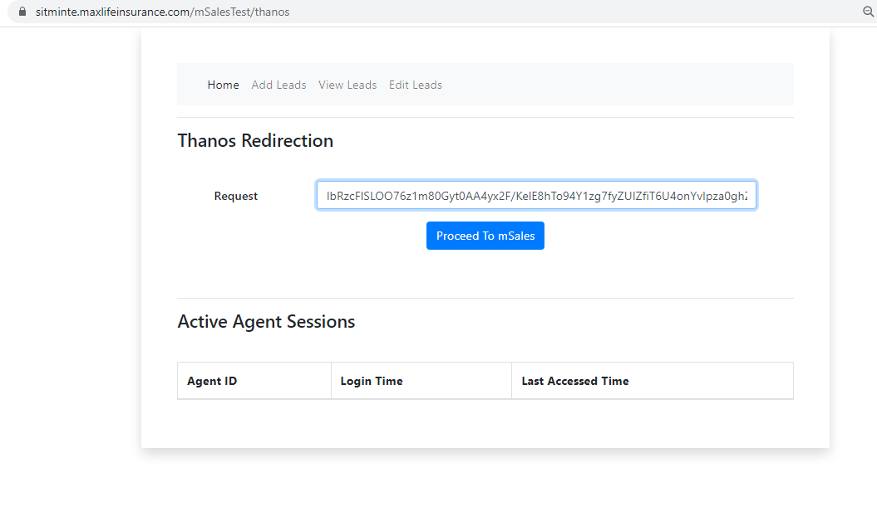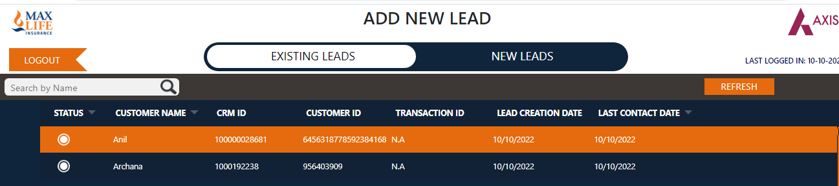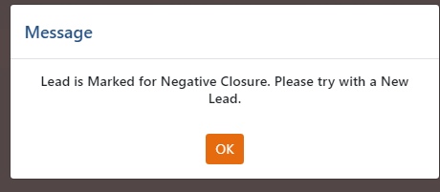

Encrypt the credentials
